

Position Announcement and Leadership Statement

Associate Vice President for Advancement and CEO of Foundation

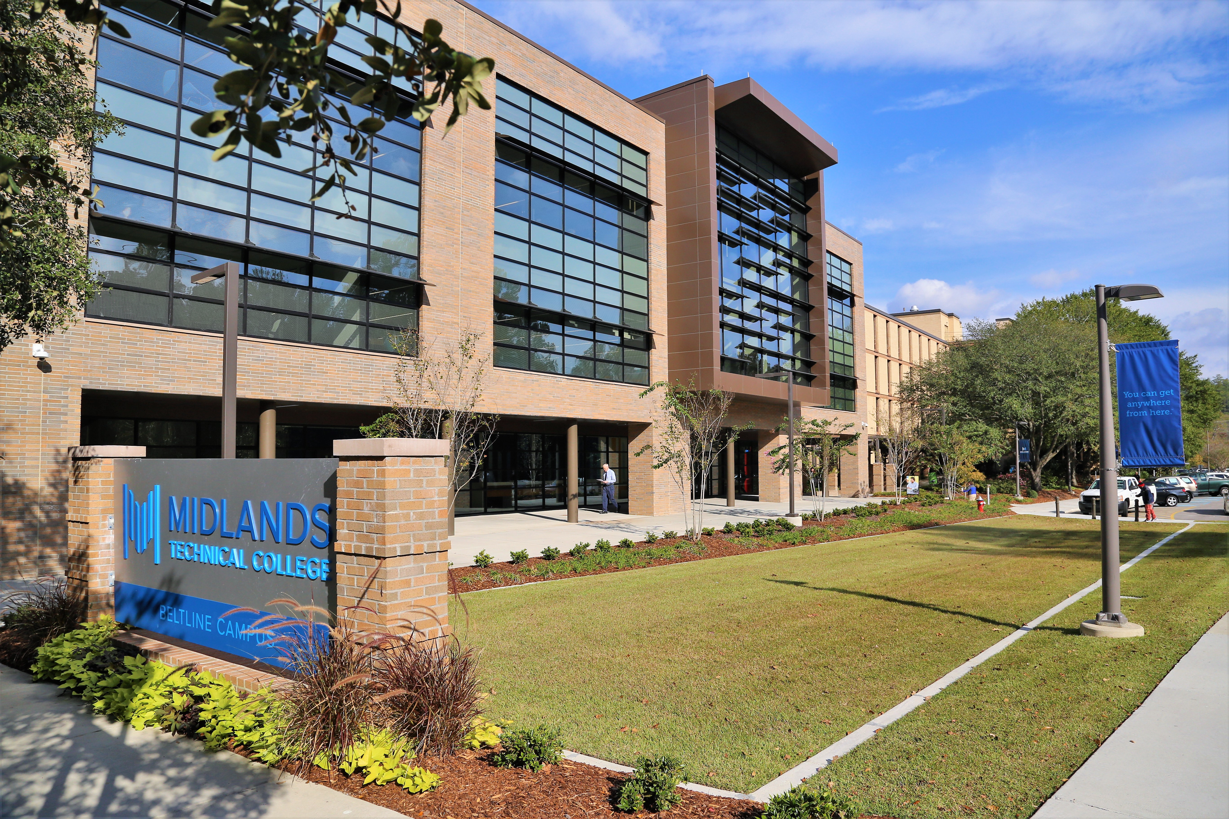

Midlands Technical College seeks an experienced, dynamic, enthusiastic AVP for the Office of Philanthropy & CEO of the MTC Foundation to provide leadership, strategic vision, and direction for all philanthropic efforts, stewardship activities, and donor relations for the college. He/she will be responsible for designing and implementing effective practices and programs that result in support for MTC, for implementing future capital campaigns, and for managing and leading the development team and volunteers to maximize their potential.
The Opportunity | Midlands Technical College

Midlands Technical College is a comprehensive, multi campus, two-year public college serving the primary region of Richland, Lexington and Fairfield counties of South Carolina. College programs and services provide accessible, affordable, quality education that prepares a diverse student population to enter the job market, transfer to senior colleges and universities, and achieve their professional and personal goals. Through its programs and services, MTC equitably provides higher education opportunities and strengthens the economic and social vitality of the community.

The Community | Columbia, South Carolina (Midlands)
The Midlands is a dynamic community in the heart of South Carolina and centered in Columbia. It is just now being discovered for its attractive, active lifestyle, affordable cost of living, and pleasant and welcoming spirit. Columbia alone has seen more than $1.3 billion in new downtown investment since 2014, including the Bull Street area and Spirit Communications Park. It is anticipated that the Bull Street development alone will result in a $1.2 billion annual economic impact and will create 11,020 permanent, high-wage jobs. Spirit Communications Park, the 2016 Ballpark of the Year, is the home to the Fireflies, Columbia’s new minor league baseball team. The area has a vibrant creative community served by Columbia Museum of Art, SC Philharmonic Orchestra, Columbia City Ballet and a myriad of performing arts groups. In addition, just minutes from downtown Columbia are limitless outdoor opportunities to enjoy three rivers, the largest freshwater lake in SC, A National Monument and numerous walking and biking trails. Columbia has received numerous accolades for its cost of living, climate, job outlook, education, arts, health care and recreation.

The Position | AVP for the Office of Philanthropy & CEO of the MTC Foundation

The AVP for the Office of Philanthropy and CEO of the MTC Foundation provides overall vision and leadership for growing the financial resources of the Foundation through fundraising activities, campaigns, donor cultivation, endowment development, planned giving, and other activities. This position is responsible for the close collaboration and communication between the Foundation Board of Directors, Commission, President, Executive Council, faculty, staff, and external stakeholders. The AVP reports directly to the President and works closely with the Foundation Board. In addition, the AVP supervises six full-time staff: Executive DOD, Director of Information Processing, Director of Communications and Stewardship, Alumni Affairs and Annual Fund Manager, Research Analyst, and Major Gift Officer.

Successful candidates for this position will exhibit the ability to:
- Serve capably as a highly visible representative of MTC in the community;
- Understand best-practice fundraising and be visibly and actively engaged with constituents and others in the community;
- Demonstrate working knowledge of innovative, cutting-edge, non-traditional methods and practices for fundraising;
- Effectively recruit, manage, and direct Office of Philanthropy staff and Foundation Board members.
- Adhere to all state and federal guidelines and regulations.

Essential duties and responsibilities:

- Work effectively with the Foundation Board of Directors, Commission, President, Executive Council, faculty, and staff to set and execute the vision for the Office of Philanthropy and Foundation.
- Responsible for leading, developing, implementing, and directing college- and community-wide philanthropic efforts that lead to increased student, faculty, and staff support and build on the culture of philanthropy.
- Remain current on issues and trends in fundraising.
- Serve on the MTC Executive Council and as the liaison to the Foundation Board.
- Work collaboratively with MTC Marketing Communications to develop appropriate and effective collateral material.
- Develop and implement division wide strategic plan with measurable goals and objectives that align with the MTC Strategic Plan.
  - This plan should include strategies to capture, retain, and upgrade gifts and support from individuals, businesses, and foundations. Goals and objectives should be assigned down to the responsible individual level and include timelines.
- Guide direct reports toward accountable, goal-oriented outcomes.
- Oversee management of the donor data base maintained in Raiser’s Edge.
- Manage budgets for alumni, development, marketing and public relations.
- Perform other related duties as required or assigned.

Qualifications/Requirements:
- A Master’s degree plus six years of progressively responsible related work experience. A combination of education and experience may be considered in lieu of the master’s degree.
- Five to seven years’ experience in a major fundraising role, including directing strategy. Directly related experience or a combination of directly related education and development experiences may be considered in place of the above requirement.
- A demonstrated ability to work effectively with diverse constituencies and a successful track record with fundraising is required.
- Experience with Raiser’s Edge donor management software or comparable products.
- An understanding of and commitment to the mission of the college and the diversity of the college’s student population.
- A demonstrated competency in oral, written and interpersonal communication skills and above average computer skills.
- The ability to exercise maturity and sound judgment, tact and discretion, professional demeanor and behavior.
- A strong work ethic, competitive nature, personal integrity, team-work approach, emotional intelligence and the ability to follow directions, college procedures and policies.
- The successful candidate must possess strategic thinking and planning skills.

Procedure for Candidacy:
Midlands Technical College has retained Capital Development Services to assist with professional recruitment. Nominations, expressions of interest, and applications can be submitted via email to searchservices@capdev.com.

Candidates should include a cover letter, a resume, and a list of three references. All material will be confidential. Additional inquiries may be directed to Capital Development Services, 336-747-0133 ext 208.


