

Position Announcement
Director of Campaigns

The Opportunity | Midlands Technical College

Midlands Technical College is a comprehensive, multi campus, two-year public college serving the primary region of Richland, Lexington and Fairfield counties of South Carolina. College programs and services provide accessible, affordable, quality education that prepares a diverse student population to enter the job market, transfer to senior colleges and universities, and achieve their professional and personal goals. Through its programs and services, MTC equitably provides higher education opportunities and strengthens the economic and social vitality of the community.
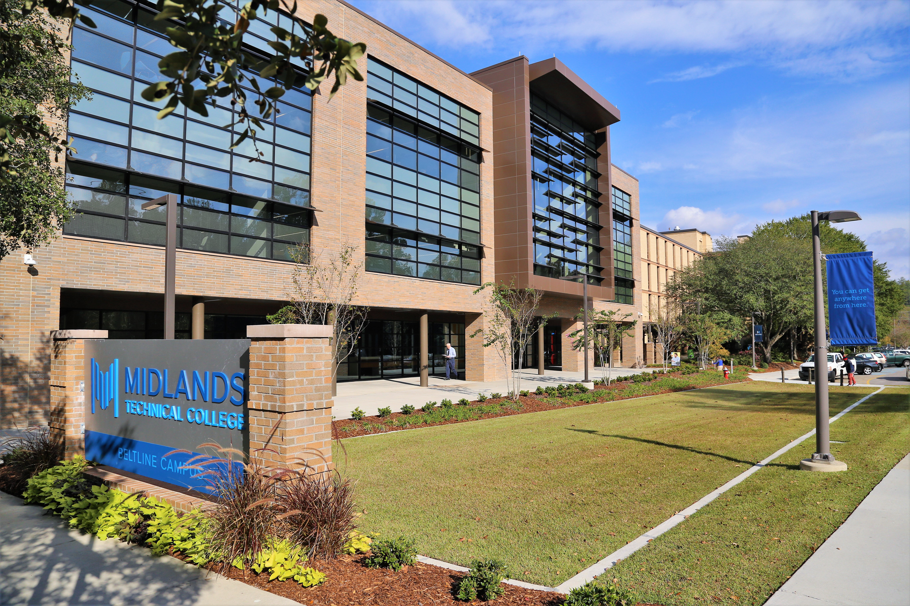

The Community | Columbia, South Carolina (Midlands)
The Midlands is a dynamic community in the heart of South Carolina and centered in Columbia. It is just now being discovered for its attractive, active lifestyle, affordable cost of living and pleasant and welcoming spirit. Columbia alone has seen more than $1.3 billion in new downtown investment since 2014, including the Bull Street area and Spirit Communications Park. It is anticipated that the Bull Street development alone will result in a $1.2 billion annual economic impact and will create 11,020 permanent, high-wage jobs. Spirit Communications Park, the 2016 Ballpark of the Year, is the home to the Fireflies, Columbia’s new minor league baseball team. The area has a vibrant, creative community served by Columbia Museum of Art, SC Philharmonic Orchestra, Columbia City Ballet and a myriad of performing arts groups. In addition, just minutes from downtown Columbia are limitless outdoor opportunities to enjoy three rivers, the largest freshwater lake in SC, a National Monument and numerous walking and biking trails. Columbia has received numerous accolades for its cost of living, climate, job outlook, education, arts, health care and recreation.

The Position | Director of Campaigns

The Director of Campaigns will have direct responsibility for the supervision of fundraising campaigns and serve as a key member of the Foundation’s advancement team. The Director will report to the Associate Vice President of Advancement, and will work closely with the President, Deans, and other volunteers and development staff to identify, cultivate, and solicit major gift prospects for campaign commitments in support of the college’s initiatives and priorities.
The Director should have a good sense of the balance between the art and science of development. He/she will oversee campaign operations in conjunction with leadership; supervise the preparation and delivery of development reports; review and approve proposals; support the identification and solicitation of major gift prospects; provide supervisory functions for major gift fundraisers; and participate in fundraising by actively assisting with major gift prospects including solicitations as appropriate. The successful candidate will have a solid understanding of best practices. The successful candidate will bring strategic vision and discipline to the program, specifically as it pertains to campaign goals and objectives. He/she will be passionate about MTC’s mission.

Essential duties and responsibilities:

- Responsible for all development activities related to campaigns including: branding, communications, donor prospecting, annual campaign and capital campaigns.
- Establish campaign solicitation priorities.
- Direct a team of major gift officers, monitor prospect activity, distribute portfolios.
- Oversee campaign budgets and campaign reporting.
- Monitor proposal deadlines, edit written proposals, and oversee proposal submission.
- Recruit and supervise campaign volunteers and committees.
- Help shape donor strategies; prepare staff and volunteers for donor meetings.
Qualifications/Requirements:
- A Master’s degree plus five years of progressive leadership experience or a bachelor’s degree plus six years of relevant program experience.
- Minimum of five years’ experience in a major fundraising role.
- Proven record of professional fundraising success, including major gift and campaign experience.
- Ability to actively engage, solicit and steward prospects and donors.
- Express maturity, personal integrity in understanding, developing and sustaining resilient relationships with donors, colleagues and senior administration.
- Entrepreneurial and goal driven with high-level of initiative and energy.
- Adept at problem solving and applying sound judgement in situations requiring independent initiative and tact.
- Excellent oral, written, and interpersonal and organizational communication skills.
- Familiarity with financial planning, tax and charitable gift laws and planned giving vehicles.
- The successful candidate must possess strategic thinking and planning skills.

Procedure for Candidacy:
Midlands Technical College has retained Capital Development Services to assist with professional recruitment. Nominations, expressions of interest, and applications can be submitted via email to searchservices@capdev.com.

Candidates should include a cover letter, a resume, and a list of three references. All material will be confidential. Additional inquiries may be directed to Capital Development Services, 336-747-0133 ext 208.


