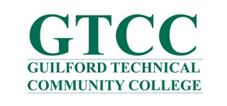

Position Announcement and Leadership Statement

Guilford Technical Community College Jamestown, NC

Executive Director of the Foundation

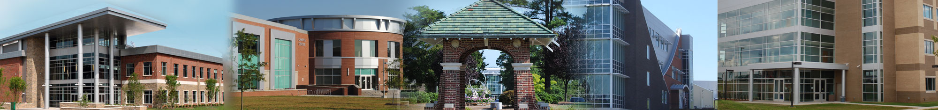

Guilford Technical Community College (GTCC), located in the rapidly growing Piedmont Triad Region of North Carolina, seeks to fill the position of Executive Director of the GTCC Foundation. GTCC is the fourth largest of the state’s 58 community colleges, serving more than 35,000 students annually through its five campuses, including its main campus in Jamestown, North Carolina. GTCC is committed to providing access to lifelong learning opportunities for personal growth, workforce productivity, and community service. GTCC proudly serves all the diverse segments of Guilford County's population, delivering quality educational programs and services, through partnerships with businesses, community groups, and other educational institutions. In addition, GTCC boasts a comprehensive educational program including 93 degrees, 25 diplomas, and 74 certificates from approximately 90 unique programs. GTCC operates from six campuses, which includes the main location at Jamestown and additional locations in Greensboro, High Point and Colfax. In addition, the Aviation Campus in Greensboro comprises three specialized aviation centers, and the College operates two small business centers. Union Square Campus, Inc., a partnership campus with UNC Greensboro, North Carolina A&T University and Cone Health, opened for nursing program classes in Fall 2016. GTCC is one of 16 community colleges honored for Exceptional Institutional Performance (EIP) in the annual performance report compiled by the North Carolina Community College System.

GTCC Campus | Jamestown, NC

Job Overview:
The Executive Director will report directly to the President of GTCC and will be an accomplished fundraising professional who focuses on details and results and who brings demonstrated administrative and managerial experience. Essential experience includes cultivation and direct solicitation of gifts, grant writing and management, donor relations, project management and communications. Working with the President of GTCC and the Foundation Board, the Executive Director will design and implement a comprehensive fundraising program to achieve sustained fundraising growth for the college; organize, direct, and coordinate all aspects of fundraising, and other resource development activities for the college; and develop and sustain a culture of operational excellence for the GTCC Foundation.
Essential duties and responsibilities:
- Design and implement comprehensive strategies to achieve sustained fundraising growth. This includes strategies to increase all areas of giving and assist in grant acquisition.
- In collaboration with the college President, serve as the primary college liaison to the GTCC Foundation Board to insure implementation of college and Board initiatives.
- Meet established benchmarks for fundraising, including personal visits to donors and potential donors.
- Establish an annual work plan with clear staff job responsibilities and expectations; provide regular feedback and coaching to improve performance and reward and recognize success.
- Organize and oversee implementation of strategic plans developed by the college and GTCC Foundation.
- Responsible for Board contributions and major gifts, faculty/staff internal campaign, annual fund, corporate, foundation, alumni, and other fund raising campaigns.
- Responsible for all fundraising and cultivation events and activities including major gifts, the internal campaign, golf tournament, donor recognition events and will develop and maintain an active Alumni engagement program and activities.
- Responsible for administration and financial stewardship of GTCC Foundation programs and funds working with the GTCC Foundation Board, college finance staff, professional services providers, financial aid, financial reporting, budget management, mini-grants, endowments, scholarships, and other programs to support the college.
- Work closely with Marketing and Public Information as part of the Institutional Advancement team.
- Oversee creation of all foundation marketing themes and materials and the GTCC Foundation website.
- Lead in delivering excellent customer service; provide positive leadership and cultivation of volunteers and other duties as assigned by the Executive Director of Institutional Advancement and the college President.
- Demonstrate and model the College’s employability skills: adaptability, communication, information processing, problem solving, responsibility, and team work.
- Serve on the college committees and community organizations as needed or assigned.
- Perform all other duties as may be assigned by the President.

Qualifications/Requirements:
- A bachelor’s degree is required; master’s degree is preferred.
- A minimum of five years of experience as a senior-level advancement professional is required that includes:
  - Annual and capital campaign fundraising;
  - Donor cultivation;
  - Accounting and reporting;
  - Event planning and coordination;
  - Leading volunteers and demonstrated supervisory and administrative responsibilities; and
  - Grant development and administration.
  - Community college fundraising experience is preferred.

- Experience working with non-profit boards either through membership or job responsibility preferred.
- Skill at creating relationships.
- Ability to provide leadership, mutual respect, and work effectively in diverse groups.
- Ability to work effectively in a changing organizational environment.
- Strong commitment to team-based management and quality of service.
- Strong written and verbal communication skills; effective public speaker.
- High-level interpersonal skills.
- Familiarity with donor/contact database such as Talisma/Donor II or similar product.
- Proficiency with Microsoft Office Suite and Excel.

Procedure for Candidacy:
Guilford Technical Community College has retained Capital Development Services to assist with professional recruitment. Nominations, expressions of interest, and applications can be submitted via email to searchservices@capdev.com.

Candidates should include a cover letter, a resume, and a list of three references. All material will be confidential. Additional inquiries may be directed to Capital Development Services, 336-747-0133 x 208.

