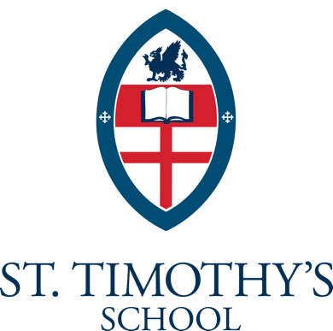

Position Announcement and Leadership Statement

Director of Advancement

Raleigh, North Carolina

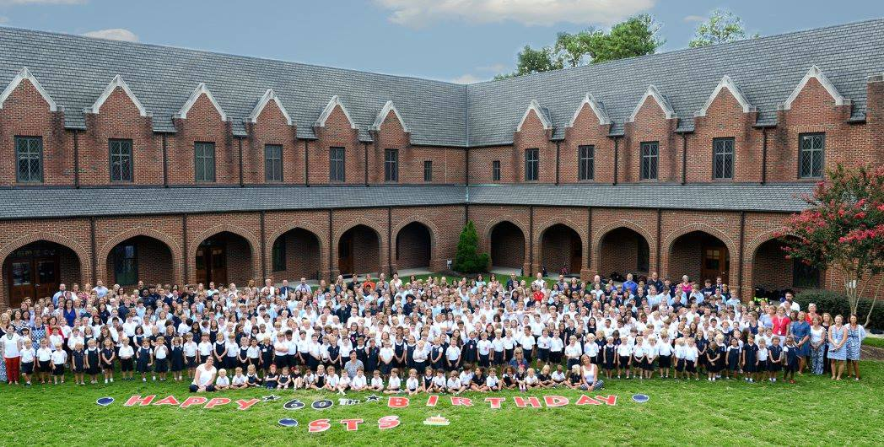
St. Timothy’s School seeks an experienced, dynamic, enthusiastic Director of Advancement to provide leadership, strategic vision and direction for all philanthropic and stewardship efforts, alumni and parent relations, communications and publications, and community relationships for the school. He/she will be responsible for designing and implementing effective practices and programs that result in annual support for the school, for implementing future capital campaigns, for growing the school’s endowment, and for managing and leading the development team and volunteers to maximize their potential. The Director of Advancement reports to the Head of School, partnering with him and working closely with the Board of Trustees and other volunteers.

The Opportunity | St. Timothy’s School
St. Timothy's School is an Episcopal preparatory school committed to educational excellence and the emotional, physical, and spiritual growth of children in an environment where traditional Christian values are emphasized. The School was founded in 1958 by St. Timothy’s Episcopal Church; sixteen children enrolled in the first kindergarten class. The school added new grades and students each year, surpassing 400 students in elementary and middle school grades within its first decade. Today the school serves approximately 520 students in grades pre-kindergarten to eighth.
Throughout our history, St. Timothy’s School has been committed to three principles established by Father Hale in the formative years: strong preparatory academics, a close-knit community where each child is known, and an Episcopal foundation of faith, hope, and love. Maintaining these traditions, while embracing innovation, has allowed St. Timothy’s School to remain a vibrant choice for parents in the Raleigh area for over sixty years.
The Community | Raleigh, North Carolina
Raleigh, NC is known for its family-friendly atmosphere, great quality of life and welcoming southern community. Raleigh is also home to the largest and oldest research park in the country. The 7,000-acre Research Triangle Park (RTP) is home to more than 200 companies and over 50,000 people with expertise in fields such as microelectronics, biotechnology, chemicals, pharmaceuticals, and environmental sciences. Home to 11 universities, colleges and numerous satellite campuses, the Raleigh area is tremendously rich in educational opportunities. It is for these reasons the region has even been named one of the best places to live in North Carolina—and the best big city in the Southeast.
The Position | Director of Advancement

The Director of Advancement is a senior management position at St. Timothy’s that is responsible for advancing the school through development work, marketing, communications, special events, and community and constituent relations. The Director of Advancement collaborates with the Head of School and the school’s leadership team to provide strategic direction to protect and enhance the school’s image internally and externally, consistent with the mission and values of St. Timothy’s School.
The Director of Advancement reports directly to the Head of School and liaises with the board’s Development Committee. In addition, the Director leads the four-person Advancement Team, responsible for philanthropic stewardship, marketing and communications, school/community events, and alumni relations. The Director of Advancement also oversees “Friends of St. Timothy’s,” the school’s vibrant parents’ association with over 30 active volunteer committees.
Successful candidates for this position will exhibit the ability to:
- Serve capably as a highly visible representative of the Head of School in the community;
- Understand best-practice fundraising among current parents, grandparents, alumni, and former donors, and be visibly and actively engaged with parents, students, colleagues, and others in the community;
- Demonstrate working knowledge of innovative, cutting-edge, non-traditional methods and practices for fundraising;
- Communicate clearly, authentically, and compellingly, both in written and electronic publications, as well as in prepared and impromptu remarks;
- Work in a mission-driven environment led by forward-thinking leaders; and
- Explain a breadth of current tax and financial knowledge that is critical to donors, as well as various instruments and options available to them.

Responsibilities of the position include:

Development:
- Identify, develop, cultivate, and solicit donor prospects, and support the board and Head of School in their cultivation and solicitation.
- Direct the annual, capital, and major gifts programs of the school.
- Develop, write, and manage grant requests.
- Coordinate all fundraising and solicitation occurring at St. Timothy’s.
- Oversee gift administration, including donor records, acknowledgement letters, mailing lists, and contact tracks.
- Maintain effective communication with the Finance Office regarding gifts management.
- Identify, train, and supervise all fundraising volunteers.

Constituent Relations:
- Oversee all parent volunteer efforts, making certain all activities follow the school’s mission and operate in concert with other school groups and activities.
- Oversee all major school events, communications, marketing, and publications to ensure they enhance mission and build community.
- Serve as an ambassador and representative for the school with local neighbors and the Midtown Raleigh/North Hills business community.

Alumni Relations:
- Develop and implement programs to increase alumni involvement and giving.
- Ensure alumni communications are varied and reach alumni population.
- Ensure alumni data is current.

The Candidate | Critical Knowledge, Skills, and Abilities

The Director of Advancement must demonstrate mastery of innovative fundraising techniques and skills in all aspects of development. He or she should have an acute sense of strategy at the individual donor level, as well as significant experience in fundraising campaigns of all types.

The ideal candidate for this position will be a proactive leader with strategic vision who possesses the ability to influence others and solve problems. He/she will be an effective communicator, through writing and public speaking, and will exhibit a professional appearance. Also, the ideal candidate will have experience with capital campaigns and major gifts; a track record of success with grants; and demonstrated skills with stewardship.

Critical knowledge, skills, and abilities required for the position include:

- Demonstrated proficiencies in school finance, fundraising, and strategic planning.
- Experience in hiring, developing, and evaluating outstanding employees.
- Substantial understanding of technology and its potential to improve donor identification, communication, and cultivation.
- Outstanding communication and interpersonal skills.
- Ability to meet expectation of regular, predictable, and reliable attendance established for all employees.
Education and Experience:
- Minimum of a Bachelor’s degree.
- Five to seven years’ experience in a major fundraising role, including directing strategy.
(Directly related experience or a combination of education and experience may be considered in place of the above requirements.)

Procedure for Candidacy
St. Timothy’s has retained Capital Development Services to assist with recruitment for this position. Nominations, expressions of interest, and applications should be submitted via email to searchservices@capdev.com.
Candidates must provide a cover letter, resume, and list of three references. All materials will be kept confidential. Additional inquiries may be directed to Jen Tozier at Capital Development Services, 336-747-0133 x 208.

