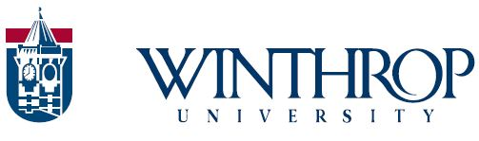

Assistant/Associate Development Officer
The Division of University Advancement at Winthrop University, a highly ranked public, comprehensive university, seeks an Assistant/Associate Development Officer.
Founded in 1886 and located in Rock Hill, South Carolina, Winthrop University offers its 6,000-plus undergraduate and graduate students an educational experience that blends liberal arts, professional programs, global awareness, and civic engagement. In its degree-granting Colleges of Arts and Sciences, Business Administration, Education, and Visual and Performing Arts, Winthrop embraces only those programs and activities that can be delivered at an exemplary level. Winthrop is well known for its inclusive and supportive campus environment and has a diverse student population that is nearly 38% minority. The values of service, excellence, diversity, community, and leadership provide the foundation for the University’s continuing development and success. Numerous national accolades reflect the sustained high quality and value of the Winthrop Experience, including the most recent U.S. News & World Report’s ranking of Winthrop as one of the top-10 public comprehensive universities in the South. Winthrop is an active member of the Rock Hill community and is recognized as a key component of the region’s economic resurgence. Approximately 20 minutes from Charlotte, North Carolina, Winthrop has direct access to and is engaged in a broad and expansive regional arts and business community. Winthrop’s beautiful campus encompasses a rich architectural blend of neo-Georgian buildings and is included in the National Register of Historic Places. The attractive recreational and research complex area that surrounds Winthrop Lake is home to Winthrop’s 18 Division I men’s and women’s sports.
Reporting to the Vice President for University Advancement, the Assistant/Associate Development Officer manages all aspects of the gift cycle for a portfolio of approximately 150 prospects who have the ability to make a gift or pledge of $25,000 or more. Primary focus will be seeking leadership annual gift commitments and pledges.
For detailed information on the position (No. 201829), please go to the Winthrop website (https://www.winthrop.edu/hr/staff/); to apply, go to the NeoGov website at www.jobs.sc.gov.
Application deadline: Dec. 8, 2017
Winthrop University is an Equal Opportunity/Affirmative Action employer and does not discriminate against any individual or group on the basis of age, color, disability, gender, national origin, race, religion, sexual orientation, gender identity, or veteran status. Women, minorities and persons with disabilities are encouraged to apply.

