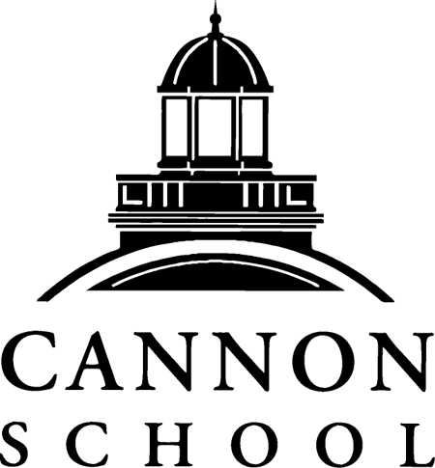
JOB TITLE: Alumni Relations Coordinator
STATUS: 12 month, Non-Exempt
AREA: Advancement
JOB DESCRIPTION:
Reporting to the Director of Advancement and working closely with Alumni Board Chairs, the Alumni Relations coordinator is responsible for the planning and implementation of programs and events that strategically engage alumni and provide tangible benefits to alumni and current students.
Serving as an ambassador, the Alumni Relations Coordinator is charged with collaborating with colleagues in the administrative offices (including, but not limited to, Advancement & Development, Marketing & Communications, College Counseling, and Admissions) to create and maintain pathways for alumni support and involvement; providing the opportunity for alumni participation that advance the goals of the School; welcoming and engaging alumni parents as members of the Cannon community; implementing the archival of the School’s historical media (documents, photographs/video, records, memorabilia); and serving as a liaison between the Alumni Association Board of Directors and the academic and administrative leadership.
RESPONSIBILITIES:
- Serve as liaison with alumni from Cannon School as well as current students, especially those in the senior class; develop programs to maintain connections with our recent graduates.
- Working with the Alumni Association, assist in the coordination of alumni events such as Homecoming, Reunions, holiday gatherings, sport scrimmages, and city-based get-togethers.
- Assist in recruiting and coordinating committees of alumni volunteers for annual reunion events and other alumni programs.
- Maintain a calendar of alumni events; assist in the production of invitations and logistical arrangements for events.
- Manage Alumni Relations budget, board slate, bylaws and meetings.
- Serve as special events coordinator for advancement events.

YEARS OF EXPERIENCE:
1-3 years of experience preferred

EDUCATION REQUIRED:
BA required

JOB REQUIREMENTS:
- Excellent communication and interpersonal skills, together with the ability to work collaboratively and courteously with colleagues throughout the School, alumni, other constituents and the public
- The demonstrated ability to strategize, implement and build innovative programs and activities, along with a talent for motivating others
- Demonstrably strong writing, planning and organizational skills
- Flexibility and initiative, as well as the ability to work independently, combined with the skills for thriving in a team environment to achieve goals
- High professional and ethical standards for handling confidential information
- Ability to organize and complete multiple tasks simultaneously with close attention to detail and prioritization to meet deadlines
- Willingness to embrace and share the school’s culture and mission
- Experience with student information systems (SIS) and databases preferred.

Cannon School does not discriminate based on race, religion, sex, or national origin. Cannon School is an equal opportunity employer.

