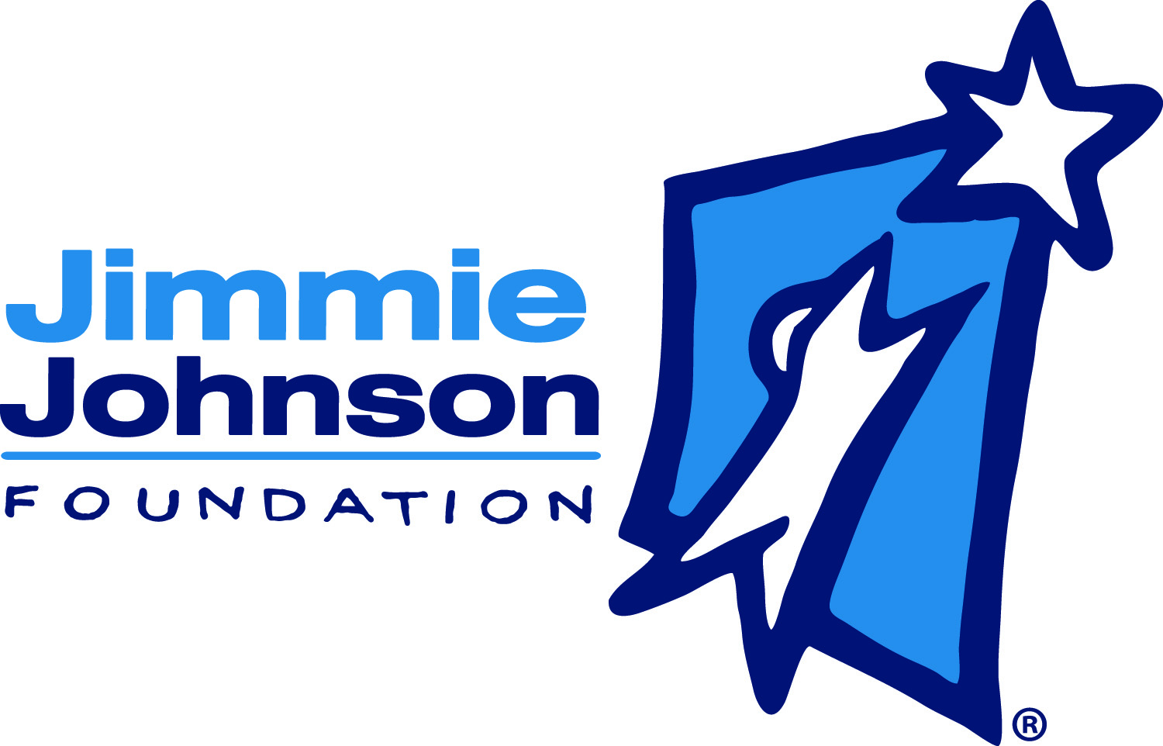

Jimmie Johnson Foundation
Job Description

Chandra and Jimmie Johnson launched the Jimmie Johnson Foundation in 2006. Johnson, the seven-time NASCAR Cup champion, drives the No. 48 Lowe’s Chevrolet SS in NASCAR’s top series. The mission of the Foundation is to assist children, families, and communities in need throughout the United States. The Foundation has committed more than $9.5 million to various charities. The Foundation currently focuses on funding K-12 public education. Go to www.JimmieJohnsonFoundation.org for more information

The JJF is seeking a full time Foundation Associate who can assist with various Foundation duties and special projects. This is an entry-level position.

FULL TIME FOUNDATION ASSOCIATE

Responsibilities
- Weekly entry of all donations (cash, checks, online…) to the donor database
- Weekly thank you/tax letters to all donors
- Provide administrative assistance for:
  - Fundraising
  - Events
  - Programs
  - Office management
- Mailings
- Manage office organization and supplies
- Field calls and requests
- Autographed item fulfillment
- Carry out tweets as approved by JJF Social Media team (ED, PD and JJR Social Media Manager)
- Monthly JJF eNewsletter
- Additional duties as needed

Job Requirements:
- 4 Year Degree, Associates or equivalent degree, or comparable experience
- Versed in MS Office Suite
- Willingness to learn and become expert in donor database system
- Good customer service skills
- Professionalism
- Attention to detail with emphasis on accuracy and quality.
- Excellent verbal and written communication skills.
- Multi-tasker; someone who is not easily flustered.
- Team player

To apply: submit a resume and cover letter, salary requirements, to Amanda@jjracinginc.com

