Senior Campaign Consultant

The Winkler Group is seeking an experienced fundraising professional to serve as Senior Campaign Consultant.

Headquartered in Charleston, SC, the Winkler Group is a national full-service fundraising firm that specializes in customized capital campaigns, planning studies, and strategic fundraising planning. Through our servant leadership model, Winkler Group clients achieve an average of 117% of capital campaign goals. The firm has experienced growth in each of its fourteen years and is today one of the most respected firms of its kind in the country.

With degrees from schools such as Duke, Georgetown, Wheaton, and William and Mary, and experience as CEOs, vice presidents of advancement, chief development officers, directors of development, and major gift officers, our consulting team represents the best and the brightest in the profession.

The Winkler Group serves leading academic institutions, national and international charities, civic and human service organizations, hospitals, as well as cultural organizations. Winkler Group consultants have served on capital campaign teams raising more than $1 billion.

Qualifications
The ideal candidate will possess the following qualifications:
- An attitude and work ethos of servant leadership.
- 10 years of professional fundraising experience, with a focus in major gifts and capital campaigns.
- Extensive experience in capital campaign management, preferably experience managing comprehensive campaigns.
- Ability and success in identifying, cultivating, and securing major gifts.
- Attention to detail, outstanding organizational skills, and ability to multi-task.
- Excellent interpersonal skills and confidence to work effectively with board members, executive leadership, staff, volunteers, donors and prospects.
- Superior verbal and written communication skills.
- Demonstrated experience and leadership in managing volunteers.
- Ability to work independently or as part of a team in dynamic, rapidly changing environment.
- Self-starter, energetic, flexible, and adaptable personality.
- Exceptional quantitative, qualitative, and analytical skills.
- Computer proficiency in MS Word, Excel, various donor database software, web applications, and knowledgeable about the role of technology and electronic communication in fundraising.
- Bachelor’s degree required. Master’s degree and/or CFRE preferred.
- Flexibility to start immediately.

POSITION DESCRIPTION
Principal Duties and Responsibilities
The Senior Campaign Consultant must work collaboratively with clients to identify, design, implement, and manage customized plans and solutions for fundraising initiatives. The Senior Campaign Consultant will be expected to travel to provide on-site leadership to clients. A sampling of responsibilities during a client’s engagement may include:
Planning Studies and Capital Campaigns
- Serve as lead counsel on planning studies and capital campaigns.
- Develop customized campaign plans, solutions, and strategies.
- Craft individual cultivation, solicitation, and stewardship strategies.
- Create campaign documents, policies and procedures, and communication strategies.
- Set campaign direction and manage day-to-day operations.
- Direct identification, research, evaluation, cultivation, stewardship and tracking of prospects and donors.
- Lead regular campaign meetings with executive leadership and staff.
- Lead, manage, and motivate volunteer committees, activities, and training programs.
- Provide regular and consistent campaign progress reports.
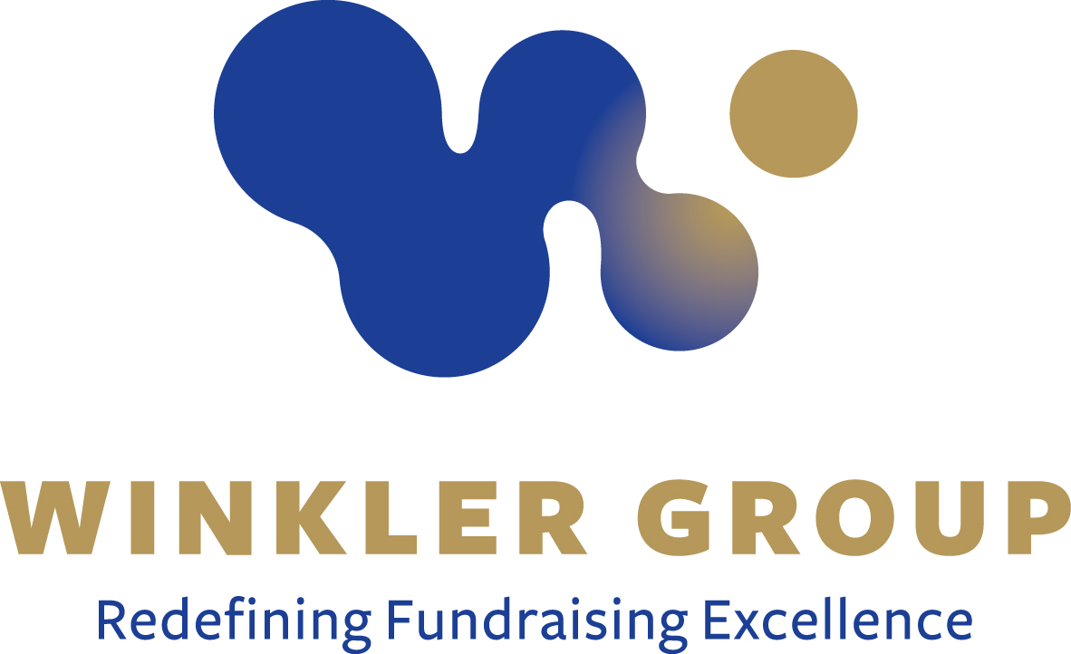
COMPENSATION, BENEFITS & REQUIREMENTS
The Winkler Group offers a starting salary range of $80,000-$90,000 with opportunity for bonuses and advancement. A generous benefits package includes medical, vacation, sick leave and holidays. The consultant must be based in the Southeastern United States or be willing to relocate to the region.
TO APPLY
Please submit resume, cover letter, recent salary history, and references to Human Resources at: Info@WinklerGroup.com. Incomplete applications will not be considered.

