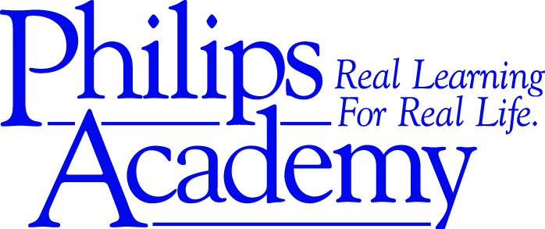

DEVELOPMENT DIRECTOR
Organization: Philips Academy
Location: 3115 Providence Road, Charlotte, NC 28211
Founded: 2005
Reports to: Executive Director

The Role: Part-Time Development Director
The Development Director will be responsible for executing Philips Academy’s fund development strategy in partnership with the Executive Director. Philips Academy’s budget has grown from $520,000 to over $1,000,000 in the last 5 years. The Development Director is being sought with the goal of increasing contributed revenue. This person must create, develop and passionately inspire donors and key constituents to maximize their financial gifts to Philips Academy assuring our students the unique opportunity for a “Real Learning for Real Life” education.
Job Responsibilities:
The Development Director will be responsible for working with the Executive Director to set and execute Philips Academy’s development strategy and goals. This will include:
- Identification and cultivation of new donors, investors, and financial partners
- Individuals: relationship building, direct mail (including annual reports, newsletters and annual fund letters), major gifts
- Stewardship and retention of existing base of donors, investors, and financial partners
- Collaborate with staff, board members and volunteers on the management and planning of fundraising events, donor receptions, and prospective donor tours
- Corporations and Foundations: relationship management, grant writing, reporting
- Long range and short term fund development planning
- Board Leadership: Along with Executive Director, engage and equip the Board of Directors to effectively support the organization’s fund development efforts
- Marketing support : social media as needed
Key Skills:
- Exceptional written communication
- Strong oral communication and presence
- Strong networking skills
- Strong attention to detail
- Exceptional organization and planning skills
- Data Analysis
- Project management and/or event planning
- Strong computer skills including but not limited to Word, Excel, PowerPoint, pdf forms, email and contact management, donor software, social media platforms

Knowledge / Experience:
- Has had training/education in fundraising and development best practices
- Has had success in fundraising and grant writing
- Has managed successful projects involving attention to detail and precise planning
Job Type: Part-Time, 20 hours per week
Salary Range: $30,000-$35,000

