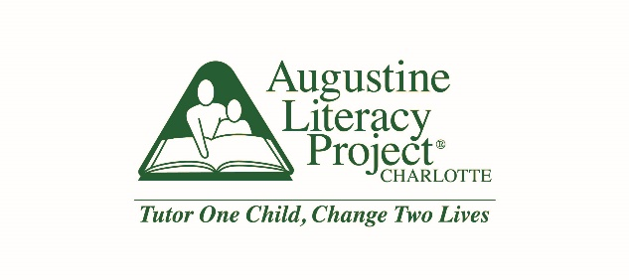

Development & Communications Director: 12 months, part-time Charlotte, NC
Reports to Executive Director

About the Organization: Augustine Literacy Project®-Charlotte
The Augustine Literacy Project®-Charlotte (ALP) recruits, trains and supports volunteer literacy tutors who provide long-term, intensive tutoring to low-income children struggling with reading. Tutors are matched with first- or second-grade students and provide twice-weekly, research-based instruction during the school day. Tutors are trained in the Orton-Gillingham approach- a multisensory, structured, explicit method of instruction- and use Wilson Reading System® materials. Seventy-eight percent of economically disadvantaged students in Charlotte are not performing on grade level in reading as they enter the 4th grade. Volunteer tutors, with quality training and ongoing support, play a critical role in addressing this issue. Augustine staff site coordinators at each of Augustine’s 11 partner schools give volunteers the support and tools they need to be successful.
The Augustine Literacy Project®-Charlotte anticipates becoming its own, independent 501c3 organization in the first half of 2018. Currently, ALP falls under the auspices of St. Peter’s Episcopal Church. During the 2017-18 academic year ALP will serve 175 struggling readers in 16 school sites in Charlotte, NC. A 2015 study administered by the UNCC Urban Institute found that ALP-Charlotte students gained an average of 1.1 grade levels in decoding and word attack in one year, based on ALP pre- and post-assessments.
Visit http://www.alpcharlotte.org for more information.

About the Role: Development & Communications Director
The Development & Communications Director will plan, execute, and lead ALP’s fund development efforts and spearhead Augustine’s donor and volunteer recruitment communications. Comprising a development and communications team of one and working closely with ALP’s Executive Director, this role has responsibilities ranging from special events, grant writing and development strategy to digital and print marketing communications to reach current and potential donors and volunteers. In addition, this person will contribute positively overall to ALP-Charlotte’s team, with a high bar for excellence. As a member of the leadership team of ALP-Charlotte, this person must passionately inspire staff, volunteers, community partners and donors to act with urgency to ensure all students develop the strong foundation in literacy skills necessary to success in school and in life.

Job Responsibilities:
- Annual Fund Development Planning – Set and track organization fundraising goals; partner with Executive Director and Board in creating and executing fund development calendar.
- Donor Relations – Develop strategy in collaboration with Executive Director to identify, cultivate, solicit and steward donors. Work with other staff to maintain existing donor database and donations processing/acknowledgement systems.
- Grants and Foundation Relations – Take responsibility for most of the grant-writing and reporting; support Executive Director as needed on select relationships.
- Events and Project Management – Coordinate major development initiatives including Year End Annual Fund Campaign, biennial Rise and Read Breakfast, Augustine Society ($1000+) Stewardship Events, and Get Rowdy for Reading. Coordinate with Board, volunteers and vendors as needed to execute event goals.
- Pipeline Management – Research, identify, and cultivate new funding sources.
- Communications & Marketing – Develop marketing materials that clearly articulate ALP’s mission, differentiators, and results while building excitement and energy around student success and volunteer efforts. Manage social media, email communication, newsletters, and other mailings.
- Volunteer Recruitment and Partnership Development - Play a supporting role in volunteer recruitment efforts, working with the Executive Director and Operations Manager as needed. Work collaboratively throughout the year with Program Staff and the Executive Director to cultivate volunteer partnerships that may also result in development opportunities.

Key Skills:
- Exceptional organization and planning
- Exceptional written communication
- Strong oral communication
- Attention to detail
- Excellent work ethic and ability to complete tasks independently
- Data analysis
- Project management skills, including event planning
- Strong computer skills including but not limited to Word, Excel, Power Point, social media (e.g. Facebook, YouTube, Instagram), CRM tools. Adobe Creative Suite (InDesign, Illustrator, Photoshop, Premiere Pro/Elements 15) a plus.
Personality / Interests:
- Have a passion for ALP’s mission and believe that effective reading instruction can change the trajectory of a child’s life,
- Enjoy meeting new people and building relationships,
- Believe in the importance of data and attention to detail,
- Operate with a sense of urgency knowing that your development efforts will ensure each child reaches his/her full potential,
- Value volunteers and believe in their ability to transform children’s lives with proper training and support,
- Interest in working in a fast-paced environment which requires thoughtful planning as well as flexibility and creativity
- Desire to work in a supportive team environment that values continuous learning
Knowledge / Experience:
- Has managed successful projects involving attention to details and precise planning,
- Demonstrated strength in business writing and strategic communication,
- Has successfully built relationships across lines of diversity.

To apply: Submit the following documents to augustineliteracyprojectclt@gmail.com.

- Resume – standard format including education, work, and volunteer experience
- Cover letter – standard, 1-page format explaining your interest in the role and why you believe you are a good fit

When submitting, use the subject line, “2018 Development & Communications Director Application”, and address correspondence to Alison Houser.

Anticipated Timeline: Applications accepted on a rolling basis

Compensation: Commensurate with experience; limited benefits available

