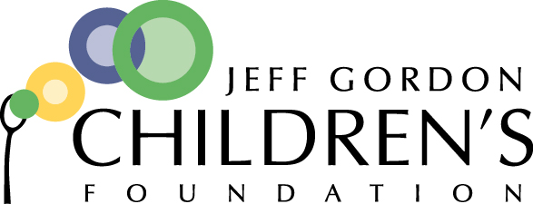

Development Coordinator

Position Overview:
The Development Coordinator position is an entry level position responsible for supporting the Director of Development to develop, promote and implement the overall strategy for business engagement, annual fund, general fundraising and stewardship for the Foundation. Daily activities will include conducting prospect research, crafting proposals and solicitation materials, running and analyzing queries, adhering to deadlines, and improving the stewardship of donors through engagement activities, record maintenance, direct correspondence, timely acknowledgements and reports.
The Development Coordinator will be responsible for generating additional revenue year over year as an integral part of the development team and for providing world-class stewardship. Additionally, this position will maintain existing peer-to-peer relationships, manage peer-to-peer fundraising software, and support general fundraising operations.
The successful candidate may be an early career fundraiser and will bring a collaborative and entrepreneurial spirit to the JGCF team.
The Development Coordinator position reports to the Director of Development.
Key Responsibilities:
Business Development
- Shared responsibility for business development goal with Development Associate and Development Director
- Support and grow business engagement through the following tasks:
  - Prospecting
    - Prospect Research
    - Identifying Contacts
    - Learning about companies’ current cause promotions and charitable efforts
  - Fulfillment
    - Finalize specifics of campaign with corporation
    - Order materials needed for event
    - Coordinate with JGCF staff on delivery of benefits (social media, banners, etc.)
    - Support corporate partner through campaign (cheerleader, answer questions, etc.)
    - Finalize how donation will be made to JGCF
  - Stewardship
    - Ensure donation is properly coded in Raiser’s Edge
    - Ensure business record is correct in Raiser’s Edge complete with contact
    - Provide any deliverables post-promotion to business (social media analytics, etc.)
- Become well-versed in the pitch and learn how to customize pitch kit

Database & Analytics
- Pulls and analyzes queries and reports for mailings, emails, stewardship and general reporting
- Creates distribution groups for email and mail campaigns
- Creates donation pages

Stewardship
- Manages the acknowledgement process including creating timely and accurate letters and mailings
- Assists with stewardship activities such as sending emails, preparing mailings, making thank you calls, etc.
- Responds to general inquiries via phone or email
- Assists with the preparation of materials, mailings, reports as needed

Peer-to-Peer Fundraising
- Maintains current peer-to-peer events and relationships to maximize fundraising potential
- Performs maintenance and updates to ensure Every Day Hero is accurate and effective
- Pulls reports from Every Day Hero as required

Support the development operations of JGCF, including but not limited to,
- Assists with special event logistics
- Codes checks for delivery to accounting
- Participates in staff meetings
- Represents JGCF at networking events and public speaking opportunities
- Assists in the day-to-day operations of the organization including but not limited to responding to outside inquiries, general correspondence and maintaining organizational records
- Other duties as assigned
Professional Skills and Experience Required:
- 3+ years of successful fundraising experience
- Demonstrated ability to design, implement and evaluate engagement opportunities.
- Outstanding communication skills
- Proficient project management skills
- Demonstrated experience in Word, Excel, PowerPoint, Raiser’s Edge

Work Habits:
- Passionate about the fight against childhood cancer.
- Uses discretion when dealing with sensitive or confidential matters.
- Excellent oral and written communication skills (including public speaking)
- Balances competing priorities while keeping constant sight of overall objectives
- A team player committed to developing and working within a collaborative environment
- Excellent organizational skills; demonstrates ability to meet deadlines & manage time effectively
- Meticulous attention to detail and follow-through performing tasks accurately and efficiently
- Enthusiastic, self-motivated and committed to excellence.
- Available for weekend and evening hours as needed.
- Ability to work as part of a team with minimal supervision

To apply, please forward your resume and cover letter (in a separate document) clearly stating your salary requirements to Courtney Hurd at churd@jgcf.org. Applications due by May 9, 2018.

