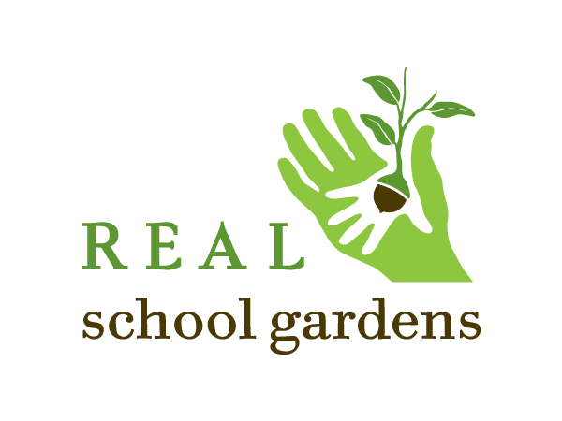

POSITION DESCRIPTION
Position Title: Development Director
Location: Carolinas Region– based in Charlotte, NC
Reports to Title: Regional Executive Director
FLSA Status: Exempt
Job Type: Full Time, Regular Staff Position

About REAL School Gardens
REAL School Gardens creates learning gardens that grow successful students. To achieve this, we do two things – build learning gardens in low-income schools, and train teachers to use gardens for academic instruction. We have recently launched an aggressive, 4-year growth plan that will expand our impact to 15 cities across the U.S. In July 2016, we launched a regional office in Charlotte, NC to serve school districts in North and South Carolina. Additional regional offices include Texas, the Mid-Atlantic, and the Southeast, as well as a National HQ office in Washington DC.
Position Overview
Working in partnership with the Regional Executive Director and the national development team, the Development Director develops and executes comprehensive fundraising strategies that increase revenue and visibility for REAL School Gardens in the Carolinas Region.
The Development Director is responsible for securing new revenue from foundations, corporations, and public funding sources and overseeing regional fundraising operations. They have significant direct revenue goals, in addition to sharing collective responsibility for the overall regional revenue goal, and are responsible for ensuring optimal partnership/donor cultivation and stewardship to successfully secure, grow and renew gifts.

The Development Director reports to the Carolinas Regional Executive Director and works closely with National Fundraising Directors, fundraising staff in other regions, and the Director of Marketing & Communications to exceed fundraising goals.

RESPONSIBILITIES
The Development Director will have a variety of responsibilities, including and not limited to:
- Execute a comprehensive fundraising plan to secure new partnerships with foundations, government agencies, local corporations, school districts and individuals for the Carolinas Region.
- Implement local development strategies, including prospect research and qualification, outreach, partnership development, solicitation, and stewardship.
- Generate and manage the region’s pipeline of funding prospects; leverage Executive Director, Education team, Board of Directors and National Fundraising Directors strategically to cultivate the broadest, most productive partnerships possible for the organization.
- Manage grant-seeking process for the region, including writing, proposal submissions, agreements, reporting and reconciliation.
- Identify and secure public funding opportunities by cultivating relationships with state and local government contacts (e.g. Board of Education, city, county and state government, etc.)
- Partner with National Director of Corporate Partnerships to cultivate, solicit, and steward corporate funders in the region.
- Renew and grow existing partnerships to achieve ambitious fundraising goals for the Carolinas Region; cultivates meaningful relationships with partners and ensures they are stewarded with excellence. Lead development and implementation of new tools and processes that will increase local fundraising capacity and drive revenue.
- Coordinate donor database activities for the region; ensure contacts with funders are recorded and coded accurately for reporting.
- Provide regular reporting on activities and progress to Executive Director and National Fundraising Directors. Collaborate with the Director of Marketing & Communications to develop collateral to support local sales, stewardship and reporting.
- Plan and execute local fundraising events as needed
- Manage Regional Development team.
- Other duties as assigned.

QUALIFICATIONS
To perform this job successfully, an individual must be able to perform each essential duty satisfactorily. The requirements listed below are representative of the knowledge, skill, and/or ability required. Reasonable accommodations may be made to enable individuals with disabilities to perform the essential functions.

- A four-year college degree in a similar field of study.
- Minimum 5-7 years of experience in nonprofit fundraising or business development with a track record of securing six-figure gifts and expanding existing donor relationships over time.
- Experience working with Board of Advisors.
- Excellent written and verbal communication skills.
- Strong interpersonal skills, with the ability to influence and engage a wide range of partners/donors and build long-term relationships.
- Strong project management and organizational skills.
- A professional and resourceful style; the ability to work independently and as a team player, to take initiative, and to manage multiple tasks and projects at a time.
- Ability to learn quickly, manage multiple tasks, and work in an environment of growth.
- Fluency in Raiser’s Edge or similar donor database(s).
- Proficiency in Microsoft Office.
- Willingness to get your hands dirty and the heart to embrace the REAL School Gardens mission and core values.

PHYSICAL DEMANDS
The physical demands described here are representative of those that must be met by an employee to successfully perform the essential functions of this job. Reasonable accommodations may be made to enable individuals with disabilities to perform the essential functions.
- Ability to work after hours and on weekends as needed.
- Ability to lift up to 40 pounds.
WORK ENVIRONMENT
The work environment characteristics described here are representative of those an employee encounters while performing the essential functions of this job. Reasonable accommodations may be made to enable individuals with disabilities to perform the essential functions.

- Normal demands associated with a deadline-driven office environment.
- The noise level is generally moderate.
- Daily contact with external customers, vendors, colleagues, associates, supervisors, and staff at all levels of the organization.

TRAVEL

- Ability to travel throughout North/South Carolina and nationally as needed.

To apply, please submit a cover letter, resume, and salary requirements through our jobs site at https://www.ikrut.com/microsite/pages/REAL%20School%20Gardens/default.html.

Salary and benefits are competitive.

