Position Announcement and Leadership Statement

Executive Director

Charleston, South Carolina

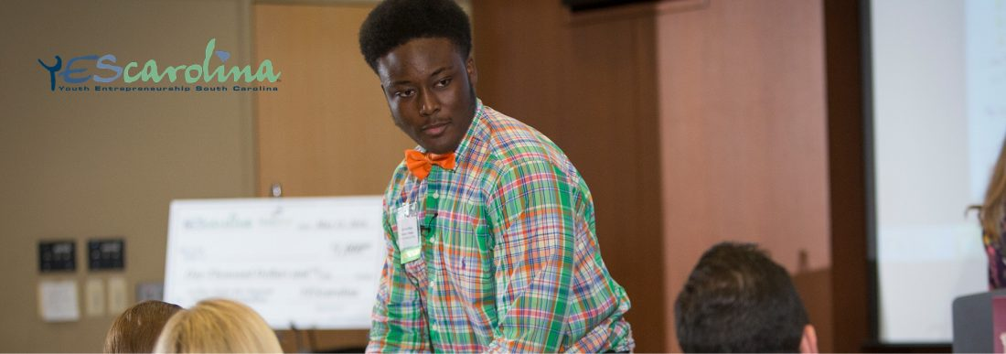

Our Mission
Teach entrepreneurship to young South Carolinians of all socio-economic backgrounds to enhance their economic productivity by improving their business, academic, communication, and life skills.

YEScarolina is seeking a visionary executive who possesses the leadership skills and experience to nurture a strong, diverse set of relationships and inspire professionals and volunteers to new heights on behalf of the organization. The Executive Director reports to the Board of Directors and is responsible for the organization’s consistent achievement of its mission, financial objectives, and strengthening YEScarolina’s statewide presence.

The Opportunity | YEScarolina
Youth Entrepreneurship South Carolina (YEScarolina) is the leading organization in South Carolina dedicated to teaching youth the principles of entrepreneurship and free enterprise. Recognizing that South Carolina’s future is dependent upon a vibrant entrepreneurial economy, YEScarolina is preparing today’s youth to be tomorrow’s business owners and business leaders.

YEScarolina has helped thousands of young people from communities statewide build business skills and fuel their entrepreneurial spirit. To date, YEScarolina has trained and certified over 1,000 South Carolina teachers about entrepreneurship. These educators, in turn, have touched and inspired over 20,000 young South Carolinian students with a thirst for entrepreneurship. YEScarolina offers entrepreneurship training to private and public school teachers statewide without charge.

The 14-year-old organization has a proven, strong track record and is on a growth trajectory. YEScarolina boasts dedicated support locally and statewide and with a successful, well-connected Board at the helm, YEScarolina anticipates an exciting era ahead.

The Community | Charleston, South Carolina
Charleston, South Carolina, is a port city founded in 1670 and is characterized by its cobblestone streets, horse-drawn carriages, and pastel antebellum houses. Not only is Charleston the oldest city in South Carolina, it’s dubbed “The World’s Best City” according to Travel + Leisure 2016. It is world-renowned for its history, architecture, cultural offerings, coastal environment, and outstanding restaurants. Charleston is part of a vibrant tri-county area of over 700,000 yet retains the charm of a small college town. Charlestonians enjoy mild winters and long summers that allow for plenty of time on the city’s world-class golf courses and miles of beaches. Charleston’s prosperity has been supported historically by the Port of Charleston, among the most active shipping centers in the nation.

In recent years, the local economy has been ignited by the aerospace industry and technology innovation, particularly in computer engineering and biomedical technology, attracting companies such as Boeing, Volvo, and DaimlerChrysler. Charleston is also seeing significant growth in early stage firms throughout the community. The start-up ecosystem is supported by many organizations such as the Charleston Digital Corridor, The Harbor Accelerator, Charleston Angel Partners, Venture South, and YEScarolina (to name a few).

The Role of the Executive Director (ED)

The Executive Director is the senior administrator and philanthropic officer, serving as a strategic partner with the Board, with overall responsibility for strategically designing, planning, and initiating programs. The ED will promote YEScarolina’s mission and vision and exemplify a passion for youth education and entrepreneurism. Specific responsibilities for this position include, but are not necessarily limited to, the following:

- Build and steward relationships on a statewide level with community leaders, elected officials at various levels, state employees, and others in influential roles to secure funding and identify areas where YEScarolina should expand.
- Create a strategic plan with the Board of Directors that emphasizes growth of mission and expansion of programs statewide.
- Identify, develop, and cultivate relationships among successful entrepreneurs and business owners across the state.
- Initiate and manage an integrated development program as principal architect of the fundraising strategy, including the creation and execution of daily, monthly, and annual action plans to maximize contributed income from diverse sources.
- Guide, support, and engage the Board and other volunteers actively in fundraising and advocacy with their professional and personal networks.
- Oversee functions related to the marketing and communications of YEScarolina initiatives, with a focus on maximizing revenue, program development, and elevated public awareness.
- Provide direction and oversight for programming and presenting activities ensuring programs are developed with YEScarolina’s mission in mind.
- Develop and ensure that annual programming, educational, and outreach plans are budgeted appropriately, in consultation with the Board, to fulfill the organization’s vision and simultaneously maximize earned and contributed income opportunities.
- Monitor YEScarolina’s financial position and make recommendations to the board and/or take action as appropriate to ensure the most effective use of financial resources.
- Demonstrate a commitment and passion for the mission.
The Candidate

The Executive Director must be an experienced manager and fundraiser with a proven track record of success. He or she should have an acute sense of strategy and a passion for entrepreneurism and education. The ED will have compelling personal qualities of integrity, leadership, and outstanding communications skills – especially as characterized by the ability to listen carefully and speak publicly on behalf of YEScarolina – exceptional judgment, and an entrepreneurial nature.

Qualities and Qualifications
- Passion for the mission of YEScarolina and demonstrated and ongoing passion for entrepreneurism and education;
- Substantial fundraising and managerial experience with demonstrated success;
- Demonstrated and consistent ability to close on major gift solicitations;
- Accomplished as a development and public-relations strategist;
- Proven management and administrative skills, as demonstrated by experience in effectively leading volunteers;
- Superior verbal and written communications skills;
- Ability to work collaboratively, engage and inspire others, and develop a rapport with many diverse people and groups, including donors and friends of YEScarolina
- Attendance at YEScarolina and community events;
- Willingness and ability to travel statewide;
- Enjoy building and growing an organization – able to problem solve and think outside the box;
- Skilled at building relationships and influencing others to join in an effort;
- A bachelor’s degree required.

Seeking an individual who is eager to use their skills, vision, drive, and charisma
to propel YEScarolina.

Procedure for Candidacy
YEScarolina has retained Capital Development Services to assist with professional recruitment. Nominations, expressions of interest, and applications can be submitted via email to searchservices@capdev.com or online by clicking here.

Candidates should include a cover letter, a resume, and a list of three references. All material will be confidential. Additional inquiries may be directed to Jen Tozier at Capital Development Services, 336-747-0133 x 208.

