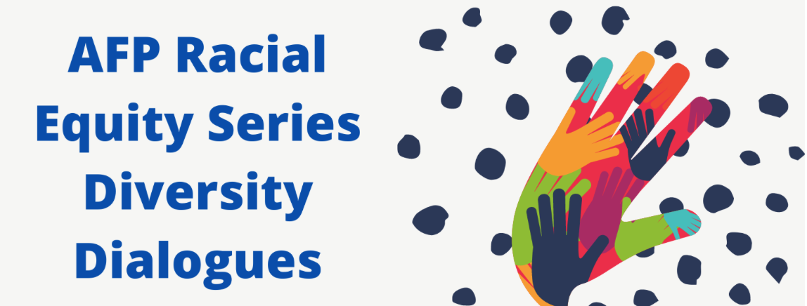
Thursday, September 10th
12 noon – 1:00 p.m.

Implementing What We’ve Learned with
Mark Dunn, VP of Organization and Leadership Development with Vidant Health

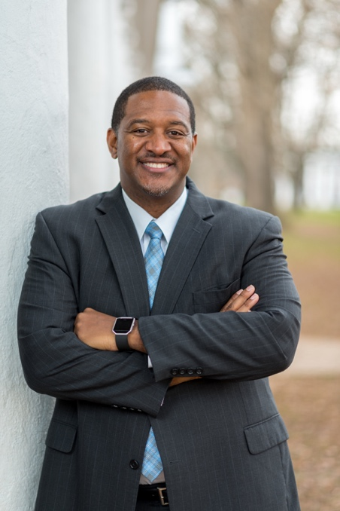
Mark Dunn is the vice president of organization and leadership development at Vidant Health System in Greenville, North Carolina. He is a seasoned human resources and talent management professional with more than 12 years of progressive leadership experience advising about human capital matters, M&A (mergers and acquisitions) integration management, talent acquisition, learning and development, and performance management within for-profit, nonprofit, and higher education organizations. Prior to working at Vidant, Mark served as a key player within HR integration at the University of Virginia (UVA) as Talent Strategy Officer, leading change and engagement initiatives following tragic events that occurred during white supremacists’ visit to Charlottesville, Va. that required medical support for injured and fatally wounded individuals. He also hosted a UVA leadership summit with speakers focusing on business operation, system alignment, diversity, equity, and inclusion. Mark has a bachelor’s degree in communication from the University of North Carolina and a master’s degree in organizational change and leadership from Pfeiffer University. He is a certified professional coach through the College of Executive Coaching. He and his wife recently began Leadership Solutions LLC, providing organizational consulting, coaching and strategic support to organization desiring a qualified, compassionate partner.

