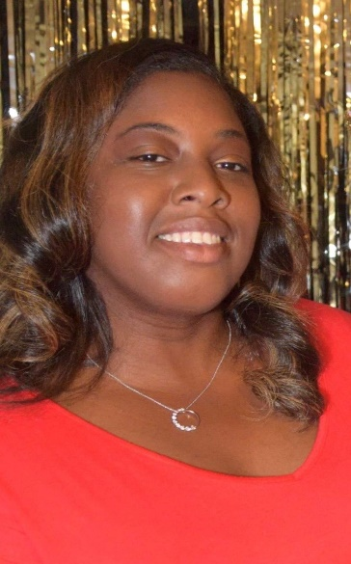
Member Spotlight: Tenille Alexander-Banner (include headshot)
Director of Corporate and Community Engagement at Safe Alliance
AFP Charlotte Member since May 2018

How did you hear about AFP and why did you decide to join?
I learned about AFP from my supervisor who is an active member and encouraged me to join. After attending a couple of the monthly lunch events, I knew AFP would be a great resource for me. I’ve dabbled in some development work in the past, but I took it on as a true profession about three years ago. It was nice to see people truly support their peers and share ideas even though they work for different organizations.

What involvement have you had in AFP so far? What has been the most beneficial?
I’ve actually participated quite a bit since joining AFP. I’ve attended monthly lunch programs, went to the 2019 NC Philanthropy Conference, taken the Fundamentals of Fundraising course, and participated in the New Fundraising Professionals affinity group. Last year I also participated as a mentee in the mentorship program. Currently, I am serving my second year on the National Philanthropy Day committee and recently joined the Mentoring committee.
How has AFP helped you in your career journey?
Nonprofit fundraising was not my chosen career path; it somehow landed in my lap and I found a passion that I didn’t even know I had. I’ve always enjoyed helping others, but I’ve mostly done that through direct service work. After taking the opportunity to join the Advancement Team I had to quickly learn how to do fundraising as a professional versus it being a hobby or volunteer project. AFP’s variety of opportunities allowed me to learn from others. AFP also helped me gain a better understanding of things like the donor cycle, annual giving, and more.
I think one of the most important things that AFP has helped me with is being confident in my natural instinct and ability to be personable and relatable and using that to my advantage as a fundraising professional. This, combined with the best practices and tools I’ve learned from AFP and its members, helped me advance to my current position and have motivated me to continue my education in hopes of seeking even greater opportunities in the future.
What are your hopes for AFP Charlotte?
It is my hope that AFP Charlotte will continue the great work that it is already doing to provide professional development to ensure that the fundraising profession is valued in our community. As a Black woman in this profession who is often the only person of color in the room, I also hope to see AFP help expand opportunities for BIPOC in this field.

