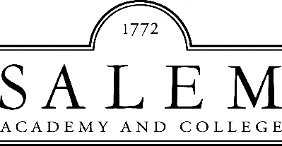

Development Officer for Health Leadership

Winston-Salem, North Carolina

The Opportunity | Salem Academy and College

Salem Academy and College, established in 1772, is the oldest continually operating educational institution for women and girls in the country. Salem College is the first liberal arts college to create a distinctive focus on health leadership, featuring an innovative curriculum that will educate women to become global leaders in all aspects of health.

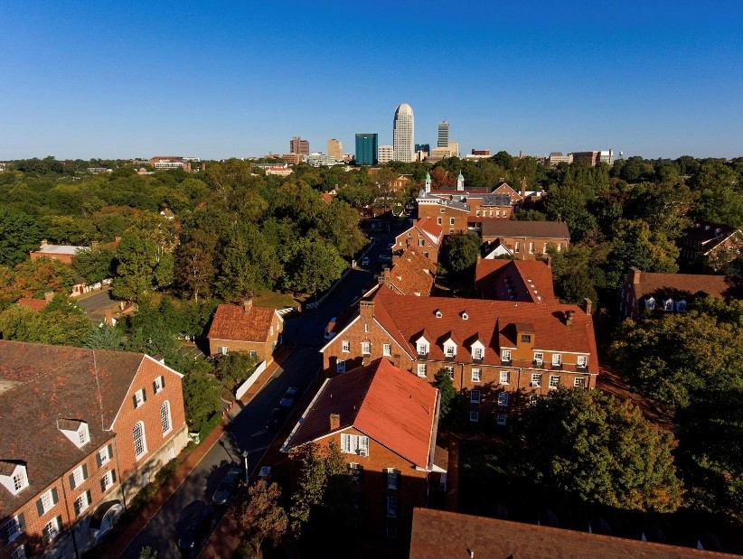

The Community | Winston-Salem, North Carolina

Winston-Salem’s history began in 1753, when the first Moravians in North Carolina settled on 100,000 acres known as the Wachovia Tract. Their vision of creating a self-sufficient community made it a haven for entrepreneurs. Twentieth-century businesses, such as R.J. Reynolds Tobacco and Hanes Co., also shaped Winston-Salem by bringing remarkable wealth to the city and endowing it with an impressive list of institutions and foundations.

Today, Winston-Salem is the fifth largest city in North Carolina and home to six colleges and universities, including Salem College, Wake Forest University, UNC School of the Arts, Forsyth Technical Community College, Piedmont International University and Winston-Salem State University. The city is frequently ranked as one of the best places to live in the US and enjoys an excellent school system and low cost of living. Visit www.winstonsalem.com for details.

The Position| Development Officer for Health Leadership
The Development Officer for Health Leadership at Salem Academy & College (“Salem”) will manage a substantial prospect portfolio of individual donors, corporations, and foundations whose gifts and grants will directly impact the development of Salem’s distinctive curricular and co-curricular focus in Health Leadership. Responsibilities will include researching and identifying prospects with interests and inclinations toward the focus, engaging these prospects through phone calls, remote meetings, face to face meetings, invitations to campus, and introductions to faculty, students and administrators. The Development Officer will work in conjunction with the Office of Institutional Advancement to further the direction, planning, implementation, and evaluation of philanthropy-related activities under the supervision of the Senior Director of Development.

Essential Duties and Responsibilities

Donor Development and Solicitation
- Research and identify major prospects (within the current donor base and new donors) with an interest and inclination for gifts to Health Leadership;
- Build and manage a portfolio of Health Leadership individuals, foundations, and corporate prospects to secure maximum support;
- Enlist the help of board members to identify and create relationships with appropriate major gift prospects;
- Develop strategies and prepare proposals for major gift prospects whose philanthropic purposes most closely parallel Salem’s Health Leadership focus;
- Work closely with volunteer boards around fundraising strategies for Health Leadership;
- Identify common priorities and work to align the prospective donor’s philanthropic philosophy with Salem’s institutional priorities;
- Encourage and prepare campus site visits (or appropriate virtual meetings) for major gift prospects;
- Work closely with the Academy and College leadership to include the President, Head of School, Vice Presidents, Deans, and volunteers on leadership prospect cultivation, solicitation, and strategies for achieving institutional priorities;
- Collaborate with the Senior Director of Development on the development and execution of fundraising goals;
- Help develop the vision and annual strategic plan for the Institutional Advancement Office;
- Work in concert with the Senior Director of Development and volunteer leadership to increase the number of donors and the level of campaign and annual giving;
- Promote a positive image and positive external relations for the institution by communicating and interacting with donors and potential donors in matters related to Advancement Services;
- Represent the institution in various activities and events near and far designed to promote the institution in particular and higher education in general, serving on appropriate boards and committees;
- Perform other duties as assigned.

Qualities and Requirements
- Bachelor’s degree in a related field and a minimum of at least five (5) years of professional fundraising experience, with emphasis on major gifts, within a health leadership corporation or health-related non-profit is preferred;
- A proven successful track record of soliciting and closing major gifts, recruiting and managing volunteers, and cultivation of major donors and donor prospects, is highly desirable;
- Proven record of successful leadership and performance at an equivalent level within an organization;
- Excellent interpersonal skills; must possess the skills to collaborate, communicate and cooperatively work with faculty, staff and administration;
- Strong organizational and planning skills, attention to detail and ability to prioritize and meet deadlines;
- Strong written and presentation skills with proven success in soliciting funds;
- Strong computer skills to include: Word, Excel, Zoom, Google Meets, and/or other online meeting tools, and the ability to conduct Internet research;
- Skilled use of Microsoft Office software, as well as presentation and website applications expected. Experience with Raisers’ Edge is preferred;
- Commitment to the values and environment of an educational institution and its mission and goals;
- Demonstrated commitment to diversity, equity, and inclusion;
- Demonstrated ability to exercise effective independent judgment and efficiently manage tasks and time;
- Ability to be analytical, use and generate statistical information for tracking and reporting on overall donor activity and giving results;
- Ability to multi-task in a fast-paced environment with fluctuating priorities and deadlines;
- Ability to deal effectively with confidential information;
- Ability to travel extensively. If driving a personal or a Salem vehicle on institutional business, a valid driver’s license and satisfactory driving record are required.
Salem Academy & College is an equal employment opportunity employer and does not discriminate on the basis of race, color, national origin, age, religion, disability status, sex, sexual orientation, gender identity, veteran status, pregnancy, or any other characteristic protected by law in its employment practices.

Click Here to Apply

Salem Academy and College has retained Capital Development Services to assist with professional recruitment. Candidates should include a cover letter, a resume, and a list of three references. All material will be kept confidential. Additional inquiries may be directed to Jen Tozier at Capital Development Services, searchservices@capdev.com or 336-747-0133 x 208.

