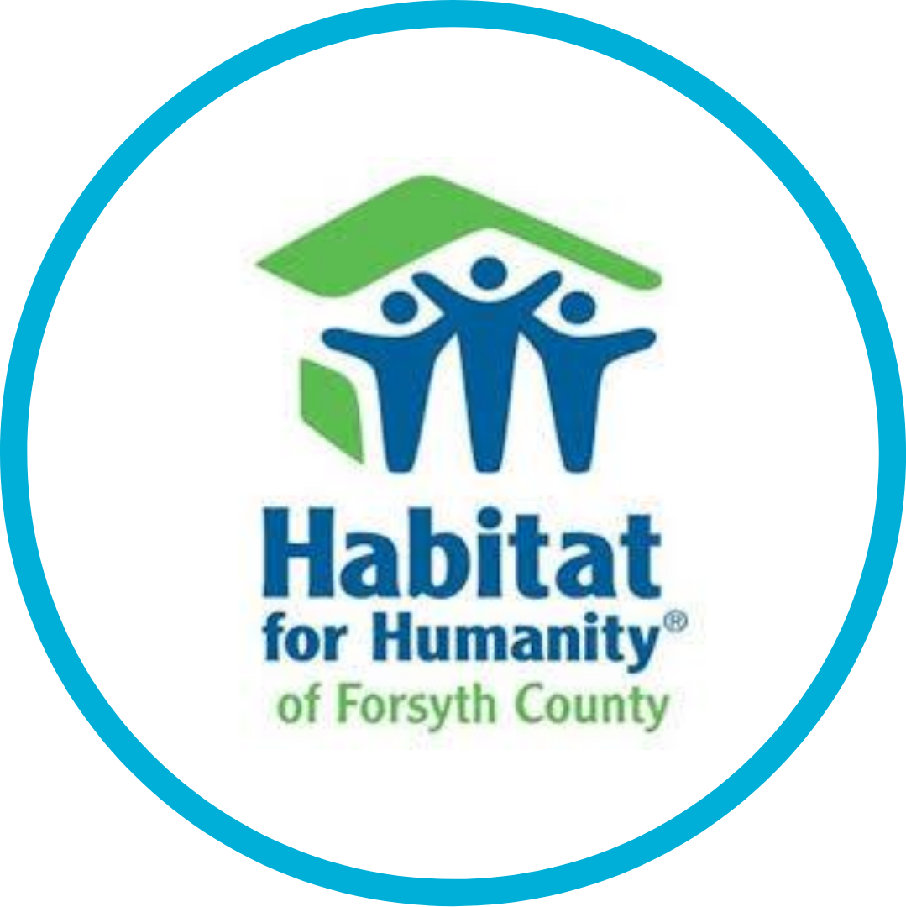

Position Announcement

Executive Director and CEO

Winston Salem, North Carolina

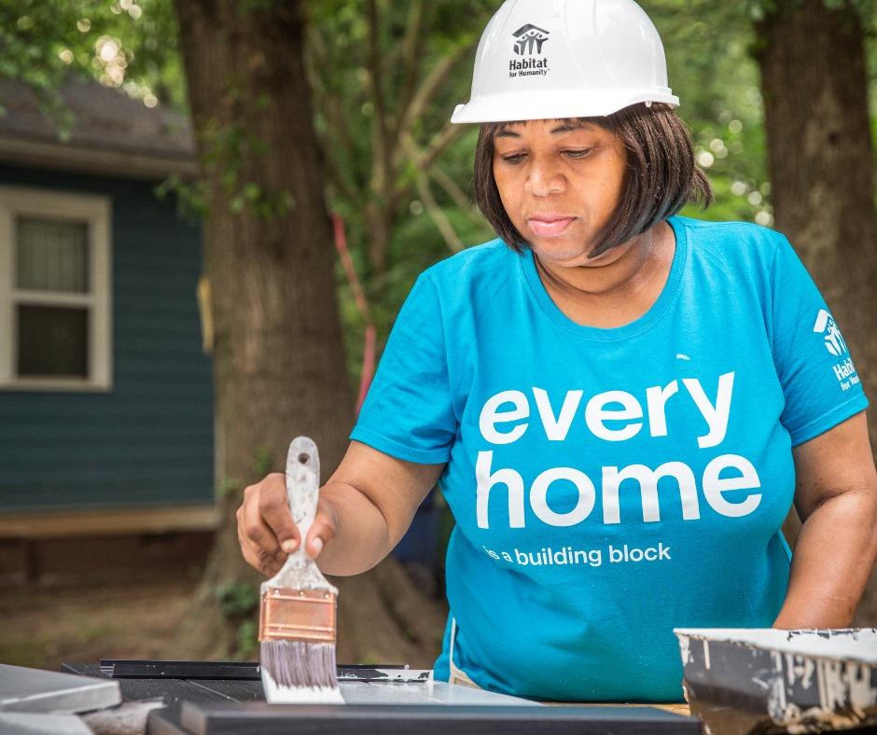

The Organization| Habitat for Humanity of Forsyth County, Inc.

Mission: Seeking to put God’s love into action by bringing people together to build homes, communities and hope.

Habitat for Humanity of Forsyth County is a non-profit, ecumenical Christian housing ministry. The purpose and goal of Habitat Forsyth is to eliminate poverty housing from Forsyth County and to make safe and affordable shelter a matter of conscience and action. Habitat invites people of all backgrounds, races and religions to build and repair houses in partnership with families in need.

Habitat Forsyth is one of the country’s leading affiliates. In 2020, Habitat Forsyth celebrated its 35th anniversary and has had outstanding success, including:
- 400+ new homes built for local families,
- 100+ families served through repairs and aging-in-place services, and
- Opening a fourth Habitat ReStore and central distribution center, reaching over $2 million in sales by fiscal year end 2021 (June 30, 2021).

As Habitat Forsyth looks to the future, their goal is to grow partnerships with other non-profits in the community, develop new neighborhoods and revitalize others with a goal of building 20+ houses annually, expand its mission into other areas of the county and to continuously improve processes to better serve the community.

The new Executive Director and CEO will inherit a successful, financially sound organization with a committed and experienced staff, hundreds of dedicated and enthusiastic volunteers and donors, an active and influential Board of Directors, and a universally admired brand name – both locally and nationally.

The Greater Community | Winston-Salem, NC

Winston-Salem is the fifth largest city in North Carolina and home to six colleges and universities, including UNCSA, Salem College, Wake Forest University, Forsyth Technical Community College, Carolina University and Winston-Salem State University. The city is frequently ranked as one of the best places to live in the US and enjoys an excellent school system and low cost of living. Situated in the Piedmont region of NC, it is filled with well-planned green spaces and is proximate to the beach and to the mountains for all kinds of outside adventures and enjoyment. Visit www.winstonsalem.com for details.

Winston-Salem, the city of arts and innovation, continues to build a diverse business base, including leading in nanotechnology research, finance, manufacturing—again reaffirming the city’s tradition of forging boldly ahead. With a strong and unwavering commitment to the arts, excellence in healthcare research and technology, and opportunities for specialized and advanced education, Winston-Salem truly is one the great small cities in the Southeast to live.

The Position| Executive Director & CEO

The Executive Director & CEO is a strong and visionary leader who works in partnership with the Board of Directors to develop goals and execute strategies that support Habitat's mission.
The Executive Director & CEO directs, supervises, integrates, coordinates and assumes overall responsibility for all areas of Habitat Forsyth’s operations and has full financial responsibility for the enterprise. The Executive Director & CEO is responsible for developing the overall strategic direction of the organization, evaluating alternative strategies and constraints, capitalizing on core strengths, and developing and implementing operating plans to achieve Habitat Forsyth’s long range and annual goals and objectives. The Executive Director & CEO will represent Habitat Forsyth, as appropriate, in its relationships with major donors and prospective donors: to maintain and enhance Habitat Forsyth’s recognized place as one of the leading non-profits in Forsyth County and as one of the leading Habitat affiliates in the nation. The Executive Director & CEO will be expected to motivate, measure, coach and mentor management, employees and volunteers to ensure optimum operating effectiveness.

Key Responsibilities:

Strategic planning, program development and administration:
- Lead a strategic planning process to develop the next three-year plan for the affiliate that will then drive the annual operating plans and key performance indicators.
- Possess strong, flexible leadership skills and be able to apply them in different situations including coaching and influencing positive change.
- Supervise and provide direction to the staff responsible for all functions of Habitat Forsyth’s construction, ReStores, volunteer management, family services, finance & mortgage servicing, site selection, human relations, marketing, administration as well as community outreach.
- Provide leadership in developing program, organizational and financial plans with the Board of Directors and staff and effectively execute the plans.
- Establish and maintain strong working relationships with all governmental agencies necessary for the organization to successfully conduct its programs – locally, nationally and statewide.
- Ensure that all required official records and documents are maintained as well as ensuring audited compliance with federal, state and local regulations and Habitat International guidelines.
- Maintain knowledge of best practices of significant developments and trends within Forsyth County and the broader Habitat community.
- Promote broad participation by volunteers in all areas of the organization's work.

Philanthropy:
- Build deep and positive relationships that yield fundraising results at all giving levels.
- Proven ability in deep and positive relationship building and track record of stewardship.
- Demonstrated skills at active listening and making the major donor ask.
- Work closely with the development staff to implement fundraising plans.
- Oversight of building new sponsorships for key events and other fundraising activities.

Communication and Public Relations:
- Communicate the vision and energize prospective donors and stakeholders across various ethnic, educational, socio-economic and religious backgrounds.
- Keep the Board fully informed on the health of Habitat Forsyth and all important factors influencing it.
- Be a spokesperson for the activities of Habitat Forsyth, including its programs and goals.
- Represent the programs and point of view of Habitat Forsyth to agencies, organizations and the public.
- Direct and be active on Habitat Forsyth’s social media channels, positively impacting the public image of the affiliate.

Staff Management:
- Attract, manage, challenge, develop and maintain an outstanding leadership group and inspire strong leaders at every level of the organization.
- Ensure that job descriptions are developed, that annual performance evaluations are
completed and that important human resource practices are in place.
- Lead and build a culture right for the affiliate in all communities served.
- Ability to validate and confirm team’s execution is aligned with strategic plan.

Budget and Fiscal Management:
- Display strong financial acumen and establish and maintain a fluid and working understanding of on-going financial statements, a command of operating ratios and success metrics, and the ability to maintain disciplined, audited financial controls and monitor constant improvement in a dynamic fiscal environment.
- Work with the staff, the Finance Committee and the Board in preparing a budget; ensure that the organization operates within budget guidelines.

Required Qualifications:

- Must understand and appreciate the mission of Habitat Forsyth and have a personal commitment to helping others that God has placed in his/her path.
- Bachelor's degree preferably in business administration, non-profit leadership and management, marketing / public relations, human resources / psychology or another related field.
- A minimum of 8 years of experience in a management leadership position is required.
- Connector, collaborator and storyteller of the mission.

Preferred Qualifications:

- Experience at an executive leadership level in the growth cycle of a business or non-profit organization of relevant size, scope and complexity.
- Master's degree in business administration, non-profit management, marketing / public relations, human resources / psychology, or another related field.
- Considerable experience in leadership roles in charitable, religious or social service organizations, indicating an understanding of how non-profits differ from for-profits.
- Demonstrated disciplined approach to the development of an inclusive work environment where diversity of thought and action is encouraged.
- Track record of consistent completion of annual reviews and staff personal and professional development plans.
- Demonstrated ability to be flexible in terms of in person and virtual workings of team members.
- Proven track record of successful social media platform knowledge and activation for marketing and philanthropy.
- Ability to work with a high volume of diverse volunteers.
- Demonstrated independent responsibility for program management and accomplishing results managing a multi-million-dollar annual budget in either the for-profit or not-for-profit world.
- Demonstrated a high level of written and verbal communication skills and be effective in public speaking and the development of presentations that inspire the audience to help Habitat Forsyth achieve its mission.
- Detail-oriented and able to work independently and in a fast-paced, multi-faceted environment.
- Experience developing fundraising campaigns and building relationships with major donors and sponsors. Experience in leadership of capital campaigns a plus.
- Ideally has knowledge of, or connections in, Winston-Salem and Forsyth County that will allow them to effectively represent Habitat Forsyth with its many external constituencies. Alternatively, the candidate will have a verifiable ability to gain the necessary knowledge and establish the proper connections in the area quickly and effectively.
- Proven track record of solid community and governmental relationships and partnerships to get work accomplished.
- Experience in residential construction, real estate or retail management.

This position is located Winston-Salem, NC. Salary and benefits will be consistent with the area and commensurate with the successful candidate’s experience.

APPLY HERE
Capital Development Services has been retained to guide the search for Habitat Forsyth. Applicants for the position must provide a letter of interest, a current resume, and a list of three professional references. Applications, nominations, and inquiries should be sent to: searchservices@capdev.com

