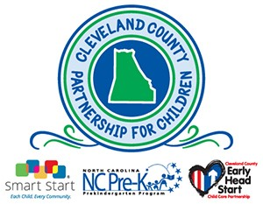

POSITION ANNOUNCEMENT

EXECUTIVE DIRECTOR

KINGS MOUNTAIN, NORTH CAROLINA

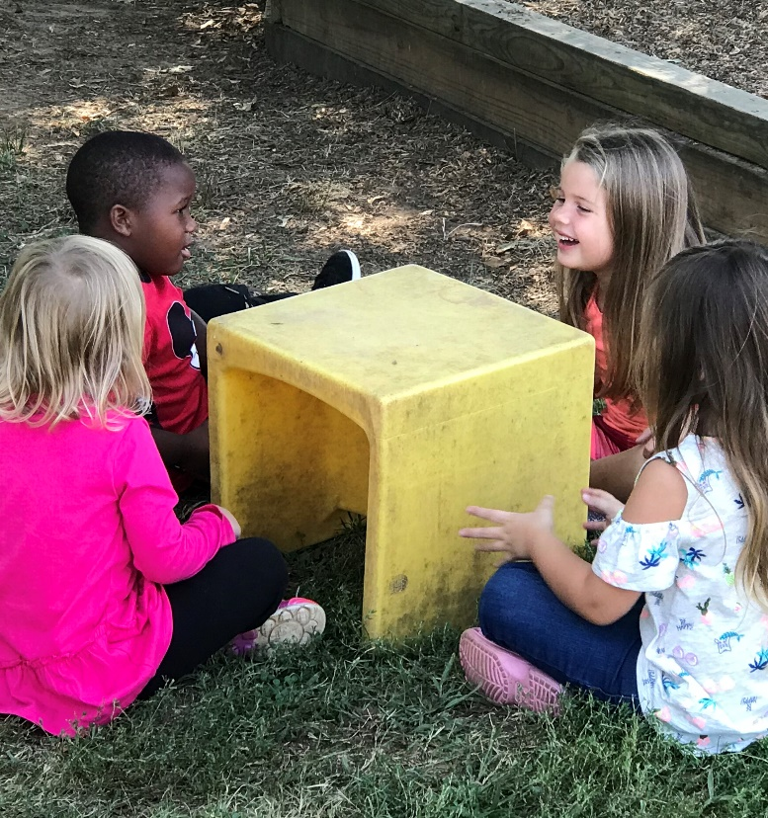
The Opportunity / Cleveland County Partnership for Children
Established in 1993 as one of North Carolina’s first 12 Smart Start Partnerships and governed by a 23-member Board of Directors, the Cleveland County Partnership for Children is a non-profit 501 (c)3 that is proud to serve as a local administrative unit for several exemplary programs for children ages 0-5. The programs include, NC Smart Start, NC Pre-K, Early Head Start, and Dolly Parton Imagination Library.
The Cleveland County Partnership for Children promotes school readiness by planning and funding programs that help our young children arrive at Kindergarten ready for school success. We form collaborative partnerships with families, child care providers, schools, businesses, local government, agencies, organizations, and the faith community to work together on behalf of young children and their families.

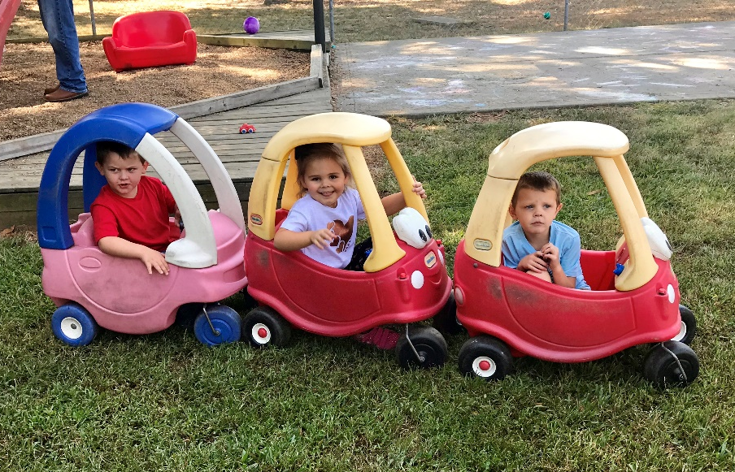

The Location / Cleveland County
Cleveland County is nestled in the rolling piedmont of the southwestern portion of North Carolina. Situated in the foothills of the beautiful Blue Ridge Mountains, the county is the gateway between Asheville and Charlotte and is centered between two of the largest metropolitan areas of the Carolinas – Charlotte and Greenville/Spartanburg. The location provides a most favorable geographic setting of steep mountains in one direction, wide beaches in the other, and nearby metropolitan centers. It is home to numerous ISO 9000 certified companies, and over 40 percent of the work force is involved in manufacturing. The local economy is diverse, with production of items that include truck cabs, compact discs, transmissions, aircraft parts, ceramic capacitor material, electric motors, and production equipment. It offers easy access to Interstate 85, 40, 26 & 77, and is part of a population in excess of 600,000 within a 35-mile radius of the county center. The Cleveland County Partnership for Children is located in the town of Kings Mountain in the eastern part of the county.

The Position / Executive Director
The Executive Director will be responsible for providing leadership and administration of the Smart Start Initiative, the NC Pre-Kindergarten Program, the Early Head Start Program and Dolly Parton Imagination Library in Cleveland County, North Carolina. The Executive Director is also responsible to the Board of Directors for management of the entire nonprofit organization including fund development, human resources, strategic planning, programs, finance, and communications. The Executive Director is the primary representative to the community and the public.
ESSENTIAL DUTIES AND RESPONSIBILITIES:
Board Governance: Works with Board to fulfill the organization’s mission.
- Responsible for leading the Cleveland County Partnership for Children in a manner that supports and guides the organization’s mission as defined by the Board of Directors.
- Responsible for communicating effectively with the Board and providing, in a timely and accurate manner, all information necessary for the Board to function properly and to make informed decisions.

Financial Performance and Viability: Develops resources sufficient to ensure the financial health of the organization.
- Responsible for the fiscal integrity of the Cleveland County Partnership for Children, to include submission to the Board of a proposed annual budget and quarterly financial statements which accurately reflect the financial condition of the organization.
- Responsible for fiscal management that anticipates operating within the approved budget, ensures maximum resource utilization, and maintenance of the organization in a positive financial position.
- Responsible for fundraising, grant writing, and developing other resources necessary to support the Cleveland County Partnership for Children’s mission.

Organization Mission and Strategy: Works with Board and staff to ensure the mission is fulfilled through programs, strategic planning, and community outreach.
- Responsible for implementation of the Cleveland County Partnership for Children’s programs that carry out the organization’s mission.
- Responsible for strategic planning to ensure that the Cleveland County Partnership for Children can successfully fulfill its mission into the future.
- Responsible for the enhancement of the Cleveland County Partnership for Children’s image by being active and visible in the community and by working closely with other professional, civic, and private organizations.

Organization Operations: Oversees and implements appropriate resources to ensure that the operations of the organization are appropriate.
- Responsible for effective administration of the Cleveland County Partnership for Children’s operations.
- Responsible for hiring and retention of competent, qualified staff.
- Responsible for signing all notes, agreements, and other instruments made and entered into and on behalf of the organization with the exclusion of contracts with funders and subcontracting agencies/organizations.

Summary of Responsibilities:
- Planning and operation of annual budget.
- Establishing and maintaining up-to-date employment policies and procedures for all functions and for the day-to-day operation of the Partnership including writing and updating position descriptions as necessary.
- Serving as the Partnership’s primary spokesperson to the organization’s constituents, the media, and the public.
- Establishing and maintaining relationships with various organizations throughout the county and state and utilizing those relationships to strategically enhance the Partnership’s mission.
- Report to and work closely with the Board of Directors to seek their involvement and approval in policy decisions and fundraising.
- Increase the overall visibility of the organization throughout the county and state.
- Supervise and collaborate with the Partnership staff.
- Lead strategic planning efforts and implement the strategic plan once it is approved by the Board of Directors.
- Oversee the organization of all Board, NC Pre-K Committee, and Early Head Start Policy Council meetings.
- Oversee and implement the Communication Plan for the Partnership and ensure the plan is updated as directed.
- Review and approve all contracts for services.
- Other duties as assigned by the Board of Directors.

QUALIFICATIONS/REQUIREMENTS:
- Bachelor’s Degree required. Master’s Degree is preferred in public administration, early education, business, public policy, education or human services-related field.
- At least 5 years of experience in management with at least 3 of these years supervising staff with total responsibility for performance reviews required.
- Preferred knowledge of the NC Smart Start Initiative, the NC Pre-Kindergarten Program, and the federal Early Head Start Program.
- Experience in financial administration and managing diversified sources of funding.
- Transparent and high-integrity leadership.
- Commitment to a family-friendly workplace culture.
- Solid hands-on, budget management skills, including budget preparation, analysis, decision-making, and reporting.
- Proven fund-raising and grants writing/reporting experience in the nonprofit sector.
- Strong organizational abilities including planning, delegating, program development, and task facilitation.
- Ability to convey a vision of the Partnership’s strategic future to the staff, Board, and volunteers and donors.
- Knowledge of fundraising strategies and donor relations unique to the nonprofit sector.
- Leadership experience working with a nonprofit Board of Directors.
- Skills necessary to collaborate with and motivate Board members and other volunteers.
- Strong written and oral communication skills.
- Ability to interface and engage diverse volunteer and donor groups.
- Demonstrated ability to oversee, collaborate with staff through a team-building approach.
- Strong public speaking ability.
- Technology skills: Excel, Word, Email, Internet, PowerPoint and Social Media

PROCEDURE FOR CANDIDATE:
The Cleveland County Partnership for Children has retained Capital Development Services to assist with professional recruitment. Candidates should include a cover letter, a resume, and a list of three references. All material will be kept confidential. Additional inquiries may be directed to Jen Tozier at Capital Development Services, 336-747-0133 ext. 208.

To Apply Online: Click Here

